Figure S2: Primary and subgroup analyses for three-point major adverse cardiovascular event associated with the use of GLP-1ra versus other glucose-lowering agents
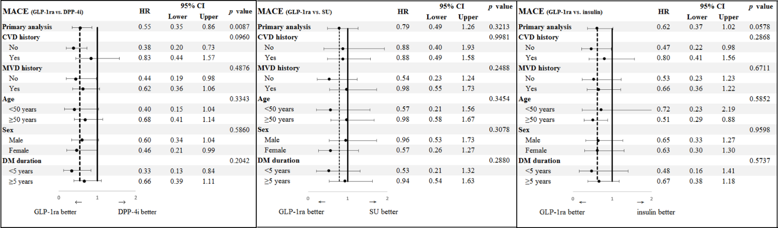
Abbreviations: MACE, major adverse cardiovascular event; HR, hazard ratio; GLP-1ra, glucagon-like peptide-1 receptor agonist; DPP-4i, dipeptidyl peptidase-4 inhibitor; SU, sulfonylurea; CVD, cardiovascular disease; MVD, microvascular disease; DM, diabetes mellitus.
Note: Three-point MACE included non-fatal myocardial infarction, non-fatal stroke, and death due to cardiovascular disease.

